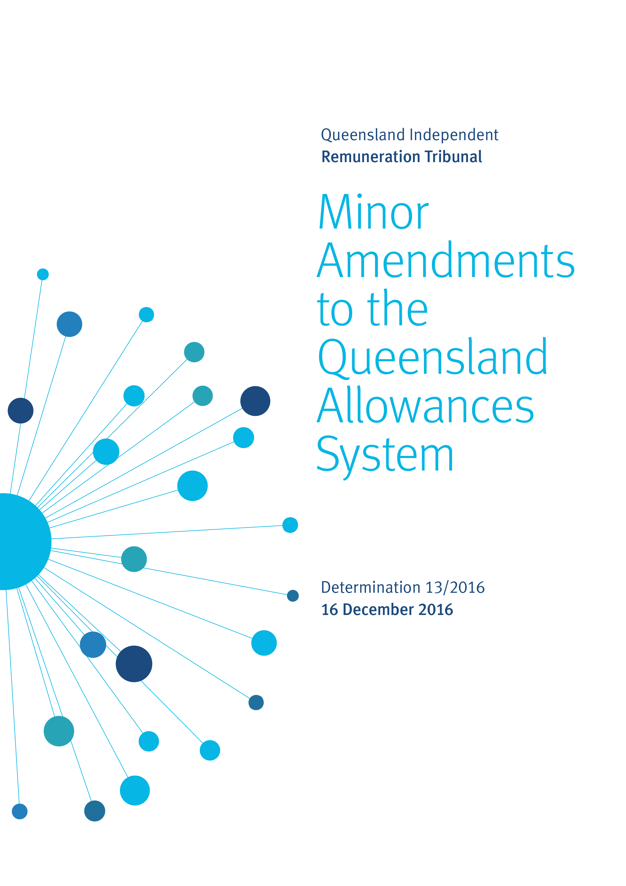

Reasons

Background
The Queensland Independent Remuneration Tribunal (the Tribunal) is an independent statutory authority established by the Queensland Independent Remuneration Tribunal Act 2013 (the Act).

The Tribunal has the power to make salary determinations in accordance with section 27 of the Act which provides for ‘…the power to make determinations about remuneration in connection with members [MPs] and former members of the [Queensland Legislative] Assembly [the Assembly]’.

The definition of ‘remuneration’ under the Act includes the annual salary (s41), the additional salary (s42) and associated allowances (s54) payable to an MP for performing roles as an office holder in addition to that of an MP in the Queensland Legislative Assembly.

Introduction
In this determination, the Tribunal is considering and making amendments to three elements of the Allowances System:
- bi-annual reporting on expenditure against allowances by Members of Parliament
- provision of reimbursement for fuel costs in locations where there are no taxis or hire cars available, and
- adjustment to the Electorate and Communication Allowance to incorporate additional cleaning and equipment costs previously provided by the Speaker under the Remuneration Handbook.
In accordance with section 30 of the Act the Tribunal has consulted with and considered the views of the Clerk on each of the matters covered in this determination.

Bi-annual reporting
Background
In Determination 1/2013 the Tribunal determined that the Clerk develop a bi-annual report on Members’ expenditure against the Electorate and Communication Allowance (formerly the Electorate and Information and Communication Allowances) in addition to an annual report on this allowance to be tabled in the Legislative Assembly before 30 September of each year.

The bi-annual (1 July to 31 December) and the annual (1 January to 30 June) reports reflect the bi-annual payment of the allowance on 1 July and 1 January respectively.

At the end of the bi-annual period (1 July to 31 December) each Member is required to verify the information provided in the electronic system developed by the Parliamentary Service and certify to the Clerk that the information in the system is correct. This report is not made publicly available, but may be requested by the Tribunal for expenditure trend and issue analysis.

At the end of the annual period (1 July to 30 June) the Clerk determines the relevant carryover amount of under-expenditure of the allowance (up to 10%) to be carried over to the next financial year as per Determination 2/2013. Members are required to certify that the reported expenditure for the full financial year acquitted against the allowance is correct. The Clerk then tables this information in an annual report in the Legislative Assembly.

Determination 1/2013 also required the Clerk to conduct a yearly random audit of acquittals and supporting documentation to test compliance. The Clerk was also required to establish information and administrative systems to facilitate the reporting process and communicate with members regarding their obligations in this regard. An electronic acquittal and information system has since been established by the Parliamentary Service (the Acquittal System) allowing real-time information flow on acquittals and expenditure against the allowance.

Analysis
The Tribunal is of the view that the bi-annual report following the first bi-annual period of 1 July to 31 December is no longer necessary for the following reasons:
- with the establishment of the electronic Acquittal System, information on trends and issues with the allowances system are available to the Parliamentary Service throughout the year
- the bi-annual report is administratively burdensome and is only used internally by the Parliamentary Service and Tribunal when required
- the annual report tabled in the Legislative Assembly covers the full financial year and expenditure against the allowance for the full annual period
- the Clerk conducts a yearly random audit of acquittals and supporting documentation to test compliance
- the carry-over of up to 10% of under-expenditure of the allowance is calculated annually, and
- while the allowance is paid bi-annually, there is no requirement for a member to spend this bi-annual payment by the halfway point of the year.

As such, the requirement for the Clerk to complete a bi-annual report following 31 December each year will be removed.

Fuel reimbursement where there are no taxis or hire cars available
Background
The Tribunal has been made aware that Members in some electorates visit towns and areas within their electorate where there are no taxis or other viable hire car arrangements. There is currently no provision for reimbursement of fuel costs for ‘borrowed’ cars in remote areas.

The Motor Vehicle Allowance (MVA) covers expenditure incurred in acquiring and maintaining a Member’s vehicle and as such cannot be used to reimburse fuel costs for a car that is not the Member’s vehicle.

Under the General Travel Allocation (GTA) the following types of expenditure related to this matter may be claimed:
- reimbursement of direct operating costs associated with a Member’s private aircraft, and
- short term car hire, taxis and connecting services.
Fuel costs directly associated with car hire and a Member’s private aircraft are reimbursed under the GTA.

Analysis
The Tribunal is of the view that provision should be made for the reimbursement of fuel costs for ‘borrowed’ vehicles for the following reasons:
- the Member is conducting Parliamentary Business and has a legitimate need for a vehicle
- the Member would have hired a vehicle if there was one available, however they cannot do so because of the location
- other vehicle owners are happy to either drive or enable the Member to borrow their car and it is reasonable that the Member wants to compensate these persons for the direct costs they incur.

To access the fuel reimbursement for borrowed vehicles a certification would need to be completed by the Member to the effect that they were:
- travelling on Parliamentary Business
- unable to secure taxi or hire car services in the particular location, and
- that they were provided with the use of a non-commercial motor vehicle by a person in which they have no legal interest and incurred fuel costs.
The certification will be developed by the Parliamentary Service in accordance with this Determination.

Any claim for fuel reimbursement will be capped at $150.

Adjustment to the Electorate and Communication Allowance
Background
The Remuneration Handbook (Handbook) currently provides for a budget allocation of $1,500 for Electorate Office cleaning. The purpose of the allocation is to keep the office interior clean and free from pests in accordance with electorate office lease agreements.

Additionally the Handbook provides for an Electorate Office Equipment Consumables allocation. This allocation provides for consumables associated with the operation of certain electorate office equipment including a suite of printing/copying equipment and may be used to meet some of the costs of those consumables including:
- plain paper
- Parliamentary crested letterhead paper
- Envelopes
- HP printer cartridges
- Ricoh Fax toners
- Ricoh Multifunction Device colour copy charges.
The CLA recently endorsed the amounts of these budget allocations.

Analysis
The Tribunal has met with the Speaker and the Clerk of the Parliament and they are of the view that the Electorate Office Cleaning allocation and Electorate Office Equipment Consumables allocation increase the complexity of the allowances system and the administrative burden on the Parliamentary Service for regulating the two allocations.

The Speaker has consulted with the Committee of the Legislative Assembly and agreed to remove these budget allocations from the Handbook on the basis that these allocations be transferred into the Electorate and Communication Allowance.

While each band of the Electorate and Communication Allowance will increase by $4,800, there will be no net increase in the amount available for Members to expend.

The Electorate Office Cleaning and Electorate Office Equipment Consumables allocations will be acquitted against the ‘office expenses’ category in the acquittal system for the Electorate and Communication Allowance.

Determination

Any inconsistencies between earlier Tribunal Determinations and Determination 13/2016 are resolved in favour of Determination 13/2016. Matters in earlier Determinations not addressed in this Determination are confirmed by the Tribunal and not amended.

Bi-annual reporting
- The Tribunal determines that the Clerk of the Parliament will not be required to produce a bi-annual report on expenditure against the Electorate and Communication Allowance.

Fuel reimbursement where there are no taxis or hire cars available
- The Tribunal determines that where a Member provides written certification that they were
- conducting Parliamentary Business,
- unable to secure taxi or hire car services in a particular location, and
- provided with the use of a non-commercial motor vehicle by a person in which they have no legal interest and incur fuel costs
the Member will be entitled to fuel reimbursement of up to $150 (as confirmed by a fuel receipt) from the General Travel Allocation.

Adjustment to the Electorate and Communication Allowance
- To facilitate the transfer of the Electorate Office Cleaning allocation of $1,500 and the Electorate Office Equipment Consumables allocation of $3,300 from the other entitlements determined by the Speaker to the Electorate and Communication Allowance, the Tribunal determines that the Electorate and Communication Allowance will increase by $4,800 to the following annual amounts effective 1 January 2017:
- Band 1 - $67,800
- Band 2 - $70,400
- Band 3 - $74,500.

Professor Anne Tiernan
Chairperson
Mr Michael Noud
Member
Ms Karyn Walsh
Member

Date of Determination: 16 December 2016

