Determination 19/2019

17 December 2019

2019 Review of Allowances

Determination 19/2019

Background and Reasons
  - Tribunal roles and responsibilities
The Queensland Independent Remuneration Tribunal Act 2013 (the Act) provides for the Queensland Independent Remuneration Tribunal (the Tribunal) to review and determine remuneration (annual and additional salaries, allowances and entitlements) in connection with members and former members of the Queensland Legislative Assembly (section 7).

Under the Act, the Tribunal may have regard to the value to the community of a member carrying out their role, functions and responsibilities and the importance of a member being appropriately remunerated for carrying out their role. The Tribunal may also consider relevant laws and any other matters the Tribunal considers appropriate including, for example, the size of an electorate (section 29 the Act).

Before making a Determination, the Tribunal must consult with and consider the views of the Clerk of the Parliament (the Clerk). In making a Determination, the Tribunal must ensure any allowances paid to a member reflect the amount of reasonable expenses incurred by a member in servicing their electorate; ensure these allowances are not a substitute for other remuneration; and ensure accommodation services or other entitlements provided for in section 55 of the Act are not taken into account - for example, electorate offices, staffing support and major items of office equipment (section 30 the Act).

  - Background
On 18 December 2018, the Tribunal handed down a comprehensive and detailed Determination 18/2018 which:
- increased the Electoral and Communication Allowance by 2.60% (rounded to the nearest $100)
- moved the electorates of Burdekin, Callide and Southern Downs to Band 4 of the Electorate and Communication Allowance
- increased the quantum of Band 4 of the General Travel Allowance by 2.60% (rounded to the nearest $100) to $79,700
- determined that the following electorates are not eligible to receive the full Daily Travel Allowance for overnight stays in Brisbane city ($315):

  - Algester
  - Aspley
  - Bulimba
  - Chatsworth
  - Clayfield
  - Cooper
  - Everton
  - Ferny Grove
  - Greenslopes
  - Inala
  - Lytton
  - Maiwar
  - Mansfield
  - McConnell
  - Miller
  - Moggil
  - Mount Ommaney
  - Nudgee
  - Sandgate
  - South Brisbane
  - Stafford
  - Stretton
  - Toohey

- renamed the Daily Travel Allowance for overnight stays in Brisbane the Parliamentary Business Overnight Rate (Brisbane)
- increased the quantum of the Motor Vehicle Allowance by 3.00% (rounded to the nearest $100)
- established that members entitled to receive air warrants may claim travel by private vehicle using a kilometric payment at Queensland public service kilometric rates up to the value of the lowest commercial flight cost excluding GST for travel between the electorate and Brisbane to which a member is entitled.
- determined that the Annual Reports on Electorate and Communication Allowance and General Travel Allocation expenditure for Members of the Legislative Assembly will no longer include expenditure exceeding 100% of the member’s allowance or allocation.

  - Submissions and consultation
Notwithstanding considerable time restraints, stakeholder engagement has informed the Tribunal’s review and the final decisions made in Determination 19/2019.

The Tribunal wrote to all Members of the Legislative Assembly, seeking feedback on the allowances system.

The Committee of the Legislative Assembly (the CLA) and the Clerk provided advice to the Tribunal about the allowances.

  - Electorate and Communication Allowance
The Electorate and Communication Allowance (ECA) is provided to cover a range of expenditure associated with:
- providing constituent assistance and service for the electorate
- obtaining and disseminating information to constituents that is relevant to fulfilling parliamentary and constituency responsibilities, and
- meeting incidental costs relating to the operation of a member’s electorate office.

The ECA may not be used to meet expenditure for:
- private or commercial purposes or to purchase goods and services where the member, or a connected party is the provider of the goods and services
- political party activity, or
- electioneering and campaigning purposes.

Determination 18/2018 increased the quantum of ECA bands by 2.60%, effective 1 January 2019. Factors considered by the Tribunal in making the decision to increase the quantum of ECA bands included economic indicators, increases or decisions regarding allowances in other jurisdictions, increased costs associated with servicing a member’s electorate, including postage and that the quantum of the ECA had not increased since 1 January 2016.

After applying the increase from Determination 18/2018 (rounded to the nearest $100) the current rate of the ECA is:
Band | Quantum of allowance
Band 1 | $69,600
Band 2 | $72,200
Band 3 | $73,900
Band 4 | $76,400

Expenditure against ECA

The Annual Report of Electorate and Communication Allowance Expenditure by Members of the Legislative Assembly for the period 1 July 2018 to 30 June 2019 provides the following data:

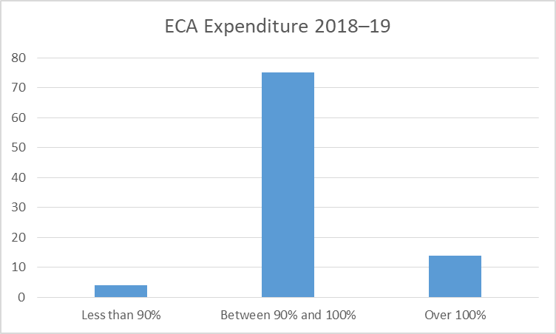

Total ECA expenditure for 2018−19 was $6,701,727.35. This is an increase of approximately $270,000 (or 4%) from 2017−18.

2018–19 was the first year that Annual Reports tabled in Parliament on ECA and General Travel Allocation expenditure for Members of the Legislative Assembly no longer included expenditure exceeding 100% of the member’s allowance or allocation.
There has not been an increase in over expenditure acquitted for 2018–19 following the amended Annual Report format.
A few members from a range of bands over expended, to a small degree, the ECA as follows:
- 1 member from Band 1
- 8 members from Band 2
- 3 members from Band 3
- 2 members from Band 4.
Of the 14 members who expended more than 100% of their ECA in 2018–19, the average overspend was $2948. This is down from 2017–18, when 21 members expended more than 100% of their ECA with an average overspend of $3342.
Six of the 14 members with ECA overspends in 2018–19 had an overspend of less than $1000.
‘Production, publication and distribution services’ had the highest proportion of expenditure (41%) during 2018–19, followed by ‘support for constituents and organisations’ (34%) and ‘office expenses’ (15%).
Within the ‘production, publication and distribution services’ ECA expenditure category, 33% ($914,080) was spent on postage and delivery in 2018–19. Australia Post has advised the basic postage rate will increase from $1.00 to $1.10 effective 2 January 2020.
The proportion of expenditure on ‘support for constituents and organisations’ has risen from 28% of total ECA expenditure in 2017–18 to 34% of ECA expenditure in 2018–19. Expenditure on ‘support for constituents and organisations’ rose by almost 26%, from $1,784,222.80 in 2017–18 to $2,244,823.37 in 2018–19. The Clerk has addressed this increase, suggesting that:
- Higher communications costs in 2017-18 associated with the 2017 Redistribution may have impacted on allowance funds available for direct support; and
- many new Members elected in November 2017 required time to set up offices, establish processes and engage with constituents and organisations before developing and establishing their own electorate financial support plans. .
Geographic considerations

The Tribunal remains mindful of the challenges faced by members whose electorates are below the 100,000 km threshold for a second electorate office, but still represent large electorates with population centres spread across the electorate.

The Tribunal reiterates its support for members wishing to use their ECA to assist in maintaining mobile offices to improve support and access to constituents in large regional electorates.

The Tribunal has noted representations about the challenges faced by members who do not have access to a second electorate office, but who still need to meet with community representatives and industry stakeholders in diverse locations in key communities within their electorates.

These matters will be addressed in future determinations.

Economic indicators

The Tribunal has considered the following economic indicators consistent with indicators considered by the Tribunal and validated by the Government Statistician in previous Determinations:
- Consumer Price Index
- Average Weekly Ordinary Time Earnings
- Wage Price Index for both the public and private sector
- Queensland’s projected economic growth, and
- Queensland Government indexation rates (see Appendix A).

Additionally, consideration has been given to any increases or decisions regarding allowances in other jurisdictions and increased costs associated with servicing a member’s electorate. The increase in postage costs will be a matter for future consideration by the Tribunal.

Decision regarding quantum of the ECA

The Tribunal has decided not to increase the quantum of the ECA bands at this stage, noting a full year of data is not yet available following the 2.60% increase from Determination 18/2018 (which applied from 1 January 2019).

The Tribunal will continue to monitor the appropriateness of the ECA and will consult the CLA on the quantum of the allowance during 2020.

The Tribunal encourages members to acquit all expenditure against the ECA, including expenditure exceeding 100%, to enable the Tribunal to consider whether any increase to the ECA is required. The Tribunal relies on the data in the Annual Reports to make evidence based decisions about any necessary increases to allowances.

  - General Travel Allocation
The General Travel Allocation (GTA) covers a range of travel expenses incurred by members when required to travel for the primary purpose of conducting parliamentary business.

In Determination 18/2018 the Tribunal decided to increase the quantum of the GTA ‘Band 4’ by 2.60%, in recognition that members in ‘Band 4’ (electorates of 100,000 and over) were expending a higher proportion of their GTA than members in other bands.

In accordance with Determination 18/2018, the GTA in place since 1 January 2019 is as follows:
Band | Quantum | Size of electorate (km2)
Band 1 (effective 25/11/2017) | $18,360 | 0 – 4,499
Band 2 (effective 25/11/2017) | $30,040 | 4,500 – 49,999
Band 3 (effective 25/11/2017) | $40,000 | 50,000 – 99,999
Band 4 (effective 01/01/2019) | $79,700 | 100,000 and over

In 2018–19, the total GTA available to all Members was $2,120,640.
The total expenditure of the GTA was $877,607.26, or 41.38% of available total GTA allocation. There was an underspend of $1,243,032.74. Any unspent GTA as at 30 June each year is considered lapsed and does not carry over.
The data on GTA expenditure provided by the Clerk shows that the overall spend of the GTA remains largely within the allocated limits, with only four Members over-expending their allocation in 2018–19. The average overspend was $886.24, with the highest being $3176.60.

It has been suggested the Tribunal consider the need for Shadow Ministers to have access to a higher GTA, noting that of the ten Members with the highest GTA expenditure for 2018−19, 7 members hold Shadow Minister roles and 3 Members are either independents or members of minor parties.

Annual acquittal data for 2018−19 indicates a significant increase in the use of hire cars (up 53.6%) and, to a lesser extent, taxis (up 34.63%). The Tribunal reiterated that short-term car hire and taxi charges are not to be used extensively as a substitute for, or in lieu of, a Member’s vehicle funded from the Motor Vehicle Allowance.

Decision regarding quantum of the GTA

The Tribunal decided not to increase the quantum of the GTA at this time but will consult with the CLA during 2020 on quantum of the allocation, including for Shadow Ministers.

  - Parliamentary Business Overnight Rate
When a Member travels for the primary purpose of conducting Parliamentary Business in Brisbane city, the ‘Parliamentary Business Overnight Rate’ may be claimed.
The cost of any claims for the Parliamentary Business Overnight Rate will not be a charge against the Member’s GTA, but the sum total of such claims in the year will be reported as a note to the Annual General Travel Allocation Report, tabled in the Parliament.
The rate claimable for the ‘Parliamentary Business Overnight Rate’ varies depending on whether members stay in the Parliamentary Annex or stay in accommodation other than the Parliamentary Annexe. Whether a member represents the following Brisbane based electorates also impacts the claimable rate:
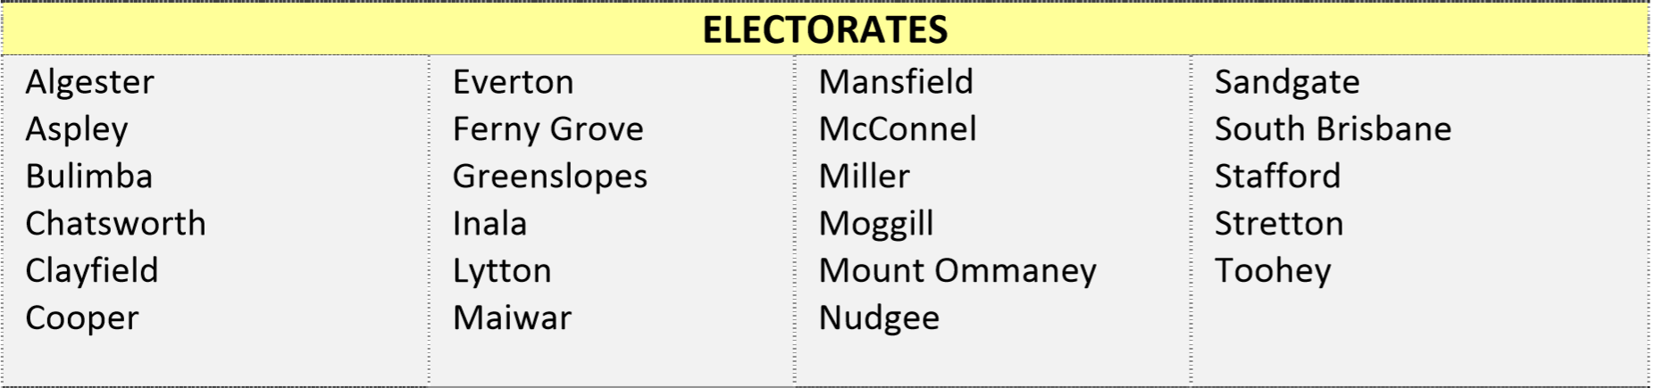
The rates claimable for the ‘Parliamentary Business Overnight Rate’ are as follows:
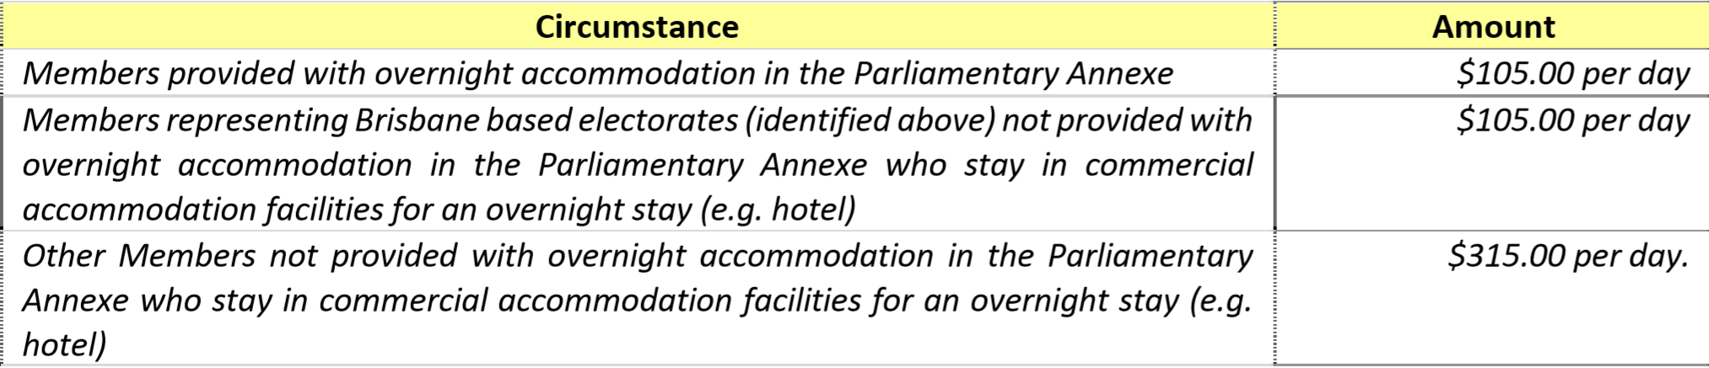
The lower Parliamentary Business Overnight Rate of $105.00 per day for Brisbane based electorates was introduced via Determination 18/2018.
In Determination 18/2018, the Tribunal committed to closely monitor the use of allowances as reported in the Annual Reports, and to consider advice from members to ensure the introduction of a lower Parliamentary Business Overnight Rate for Brisbane electorates does not have negative ramifications. No feedback has been received to indicate that the lower Parliamentary Business Overnight Rate for Brisbane electorates has adversely impacted on those Members’ ability to serve their electorate by attending parliamentary business.
Quantum
In 2018–19, 66 Members claimed the Parliamentary Business Overnight Rate with an average of $6,592.88 claimed.
The overall amount claimed by Members in 2018–19 was $435,130, up from $402,780 in 2017–18.
Decision regarding quantum of the Parliamentary Business Overnight Rate

The Tribunal has decided not to increase the quantum of the Parliamentary Business Overnight Rate at this stage.

  - Motor Vehicle Allowance
The Motor Vehicle Allowance (MVA) is provided to cover expenditure incurred in acquiring and maintaining a Member’s vehicle, in recognition that Members are expected by the community to attend events and liaise with constituents across their electorate.

In Determination 18/2018, the Tribunal decided to raise the quantum of all MVA bands by 3.00% (rounded to the nearest hundred) from 1 January 2019, in recognition of increased registration fees, running costs, insurance premiums and fuel prices.

Following Determination 18/2018 the MVA provided is as follows:
Band | Quantum | Size of electorate (km²)
Band 1 | $26,300 | 0 – 1000
Band 2 | $33,000 | 1001 – 10,000
Band 3 | $43,300 | 10,001 and over

As the MVA is not acquitted due to taxation implications, the Tribunal relies on anecdotal evidence provided by Members to assess the adequacy of the MVA.
One Member, from a Band 3 MVA electorate, provided feedback to the Tribunal indicating that the current MVA is insufficient to meet the needs of his electorate.
The Tribunal has considered various indicators including registration fees, running costs and fuel prices.
Decision regarding quantum of the MVA
The Tribunal has decided not to increase the quantum of the MVA bands at this stage, noting a full year of data is not yet available following the 3.00% increase from Determination 18/2018 (which applied from 1 January 2019).
The Tribunal will continue to monitor the appropriateness of the MVA and encourages members to provide feedback on the adequacy of the MVA to enable the Tribunal to consider whether any increase to the MVA is required. The Tribunal relies on anecdotal evidence provided by Members to assess the adequacy of the MVA in order to make evidence based decisions about any necessary increases.

Air Warrants (Alternate Travel)
Members representing 24 regional electorates are provided with an allocation of ‘Air Warrants’ to facilitate commercial air travel from a Member’s electorate to Brisbane and/or return. The long-standing principle is that remote/regional MPs should not be disadvantaged in terms of travelling to and from Brisbane to conduct Parliamentary Business.
The decision to enable electorates to claim Air Warrants is largely based on the availability of a regular commercial air service to/from Brisbane in the electorate (or just outside the electorate) and the distance of the electorate from Brisbane and the practicality of driving a vehicle from the electorate to Brisbane.
Eligible members are issued with 60 Air Warrants per financial year. Each Air Warrant may be exchanged for a one-way business class commercial airline ticket only (i.e. 30 return flights each financial year).
In Determination 18/2018 the Tribunal decided to allow regional members the opportunity to convert their air warrant allocations for a kilometric rate of reimbursement under the provisions for ‘Alternate Travel’. Members are able to claim for travel by private vehicle – kilometric payment (at public service kilometric rates) up to the value of the lowest commercial flight cost (excluding GST), for travel between the electorate and Brisbane to which a member is entitled.
No submissions have been received from any of the 24 eligible Members regarding the current allocation of 60 Air Warrants per financial year.
Quantum
For 2017–18, eligible Members utilised $331,387.83 worth of Air Warrants.
For 2018–19, eligible Members utilised $430,923.96 worth of Air Warrants. This represents a 30% increase in the utilisation of Air Warrants compared to 2017–18.
The lower level of utilisation of Air Warrants in 2017–18 could be partially attributed to the timing of the 2017 election, which meant there were two less sitting weeks in 2017–18 (13 sitting weeks) than in 2018–19 (15 sitting weeks).
Only two Members claimed Alternate Travel.
Decision regarding Air Warrants
The Tribunal is satisfied with the current Air Warrants arrangements.

Pro-rated allowance payments due to 2020 State Election

The Clerk has requested that the Tribunal consider the reintroduction of pro-rata payments for certain allowances in the period leading up to the 2020 State Election.
The Clerk is conscious that Members’ expenditure does not always occur uniformly across the year, which can cause issues when the dissolution of Parliament requires allowance payments to be pro-rated. Any expenditure over the pro-rated allowance caps must be repaid if the member is not re-elected.
In light of the move to fixed date elections, and to provide Members with sufficient time to plan and schedule allowance expenditure commitments, the Clerk has requested a pro-rata payment arrangement for all Member allowances be introduced in the lead up to the election. This will reduce the risk of defeated Members being exposed to large allowance repayments.
The Tribunal supports the introduction of a pro-rata payment arrangement for all Member allowances in the lead up to the 2020 State Election.
The pro-rata arrangements will be as follows:
- pre-paid ECA bi-annual payments normally scheduled for 1 July each year (covering period 1 July to 31 December) will be pro-rated for the period 1 July to 30 October 2020
- pre-paid MVA quarterly payments normally scheduled for 1 July each year (covering period 1 July to 30 September) will be altered to include one additional month to align with 30 October 2020 (day before election date)
- for other allocations not prepaid in advance (e.g. GTA) no changes are proposed.
In the case of allowances under (a) and (b) above, immediately following the 2020 State Election, all elected Members (including both new and returned Members) will receive pro-rata allowance payments for the period from 31 October 2020 (election date) to 31 December 2020. Normal allowance payments in accordance with standard scheduling under the Members’ Remuneration Handbook will then recommence from 1 January 2021.
  - Concluding statement
The Tribunal intends to consider a number of matters raised about allowances above during the 2020 calendar year.

Determination 19/2019
Any inconsistencies between earlier Tribunal Determinations and Determination 19/2019 are resolved in favour of Determination 19/2019. Matters in earlier Determinations not addressed in this Determination are confirmed by the Tribunal and not amended.
  - Electorate and Communication Allowance
- The Tribunal decided not to increase the quantum of the Electoral Communication Allowance bands at this time, noting a full year of data is not yet available following the 2.60% increase from Determination 18/2018 (which applied from 1 January 2019).

- The Tribunal will continue to monitor the appropriateness of the Electoral Communication Allowance and will consult the CLA on the quantum of the allowance during 2020.

- The Tribunal encourages members to acquit all expenditure against it, including expenditure exceeding 100%, to enable the Tribunal to consider whether any increase to the Electoral Communication Allowance is required.

- The Tribunal will liaise with the Clerk in relation to assistance for Members to maintain mobile offices.
General Travel Allocation
- The Tribunal decided not to increase the quantum of the General Travel Allocation at this time but will consult with the CLA during 2020 on quantum of the allocation, including for Shadow Ministers.

Parliamentary Business Overnight Rate
- The Tribunal decided not to increase the quantum of the Parliamentary Business Overnight Rate.
  - Motor Vehicle Allowance
- The Tribunal decided not to increase the quantum of the Motor Vehicle Allowance bands at this stage, noting a full year of data is not yet available following the 3.00% increase from Determination 18/2018 (which applied from 1 January 2019).

- The Tribunal will continue to monitor the appropriateness of the Motor Vehicle Allowance and encourages members to provide feedback on the adequacy of the Motor Vehicle Allowance to enable the Tribunal to consider whether any increase to it is required.
  - Air Warrants (Alternate Travel)
- The Tribunal is satisfied with the current Air Warrants arrangements.
  - Pro-rated allowance payments due to 2020 State Election
- The Tribunal supports the introduction of a pro-rata payment arrangement for all Member allowances in the lead up to the 2020 State Election.

- The pro-rata arrangements will be as follows:
- pre-paid Electoral Communication Allowance bi-annual payments normally scheduled for 1 July each year (covering period 1 July to 31 December) will be pro-rated for the period 1 July to 30 October 2020
- pre-paid Motor Vehicle Allowance quarterly payments normally scheduled for 1 July each year (covering period 1 July to 30 September) will be altered to include one additional month to align with 30 October 2020 (day before election date)
- for other allocations not prepaid in advance (e.g. General Travel Allocation) no changes are proposed.

- In the case of allowances under (a) and (b) above, immediately following the Election, all elected Members (including both new and returned Members) will receive pro-rata allowance payments for the period from 31 October 2020 (election date) to 31 December 2020. Normal allowance payments in accordance with standard Handbook scheduling will then recommence from 1 January 2021.

Date of Determination: 17 December 2019
Effective Date: 17 December 2019

_______________________ ___________________ ___________________
Mr Walter Tutt Ms Jill Lang Professor Patrick Weller
Chairperson Member Member

Appendix A – Economic Indicators

Indicator | Annual rate
Average Weekly Ordinary Time Cash Earnings¹
- Australia | 3.1%
- Queensland | 2.3%
Consumer Price Index² | 1.9%
Wage Price Index³ | 2.1%
- Private Sector | 2.0%
- Public Sector | 2.3%
Queensland economic growth⁴
- 2019-20 | 3%
- 2018-19 | 2.5%
Queensland Government indexation rates for 2019-20
- Fees and charges⁵ | 2.25%
- Community funding/grants⁶ | 2.8125%
Notes:
- ABS 6302.0 - Average weekly ordinary time cash earning (including amounts salary sacrificed), Full-time adults, persons. Change over the year to May 2019 (%).
- ABS 6401.0 - Brisbane. Change over the year to September quarter 2019.
- ABS 6345.0 - Total hourly rate (excluding bonuses), Queensland. Change over the year to September quarter 2019.
- 2018-19 is an estimate based on the Queensland State Accounts; 2019-20 is a forecast from the Queensland State Budget.
- As per Budget Paper 4 (page 7), fees and charges will increase by 2.25% in 2019-20, consistent with the CPI projection at 2018-19 MYFER.
- As per Community’s SDS (page 2), Indexation of 2.8125 per cent will be applied in 2019-20 to the State funded component of existing, ongoing, operational service arrangements with non-government organisations.

